Scott Tabaka
Instructor: Dr. Mark Hauschild
CmpSci 4732 Summer 2019
Due Date: 8/8/2019

Project #3

Task 1

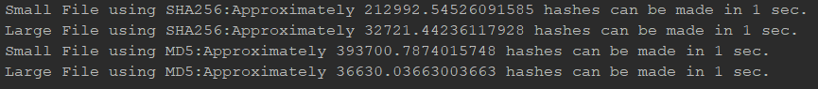
 | Total Hashes | Hashes per second | Maximum time to brute force in years | Average time to brute force in years
10B file using SHA-256 | 16⁶⁴ | 212993 | 1.73E+064 | 8.64E+063
5KB file using SHA-256 | 16⁶⁴ | 32721 | 1.13E+065 | 5.63E+064
10B file using MD5 | 16³² | 393701 | 2.75E+025 | 1.37E+025
5KB file using MD5 | 16³² | 36630 | 2.95E+026 | 1.48E+026

System Specs:
Processor: Intel i5-4300 @1.9 GHz 2.5Ghz
RAM: 16 GB
Hard drive: Samsung SSD 860 EVO 250GB

Task 2

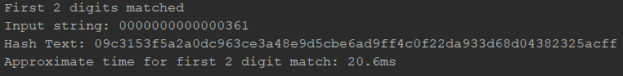
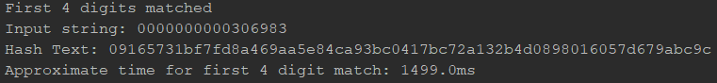
Date to match: “0916”

Time for each pair to match appears to go up exponentially similarly to 16² and 16⁴ respectively.
Total # of hashes | n(x) | ms(y) | Time in min:sec
16² | 2 | 21 | 0:0.2
16⁴ | 4 | 1499 | 0:1.5
16⁸ | 8 | 107000 | 1:47

Using (n for x) and (ms for y) I used (y=K*x^{p}) to calculate the following to estimate time for a match.

P = log(1499/21)/log(2)
K = 21/2^{log(1499/21)/log(2)}
y = 21*(x/2)^{log(1499/21)/log(2)}

Estimated time for 8 matches is 107000ms which is 1 minute and 47 seconds.

Task 3

x | y
10 | 5.68E+71
20 | 2.38E+71
30 | 1.63E+71

Using the first three digits and (y=K*x^{p}) the following was calculated.

P = log(163/568)/log(3)
K = 568/10^{log(163/568)/log(3)}
y = 568*(x/10)^{log(163/568)/log(3)}

Graph of x with help from desmos.
